Board meeting
23.05.17
Agenda | Time: 11.00 am  Venue: Basement Lounge, Hat Factory, 65-67 Bute Street, Luton LU1 2EY  Contact: 020 3176 2999

*Refreshments will be available for members from 10.30 am.
The meeting will be held in private throughout as if falls during the pre-election period relating to the General Election on 8 June 2017.

Members: Jackie Ballard, Alan Benson, Richard Dilks, Glyn Kyle, Stephen Locke (Chair), Abdi Osman, John Stewart

Guests for Items 1-8: Neil Middleton, Association of Public Transport Users;
Arthur Taylor, Bedford Commuters Association

- 11.00 Resolution to move into confidential session
To resolve, under section 15(2)(b) of schedule 18 of the Greater London Authority Act 1999, that by reason of the confidential nature of the item(s) to be discussed, and in light of the General Election due to take place on 8 June 2017, it is desirable in the public interest that the public should be excluded for the meeting.

- Apologies for absence and declarations of interest
All members have been asked to make a standing declaration of interests which can be consulted at the London TravelWatch office or viewed on the internet at: http://www.londontravelwatch.org.uk/home/declarations_of_interest. If any item on this agenda requires a specific declaration to be made, members are requested to do so.

- 11.05 Chair’s activities and Transport Focus update

- 11.10 Minutes
To approve the public minutes of the Board meeting of 11 April 2017.

- 11.15 Matters arising (LTW551)
To note a report on matters arising from previous meetings.

- 11.20 Key activities (LTW552)
To note a report on activities undertaken by members and/or officers since the last meeting.

- 11.30 Ticketing arrangements and fare levels (LTW553)
To consider a report on ticketing arrangements and fare levels affecting passengers in Luton and the surrounding area.

- 12.15 Franchising issues (LTW554)
To consider a report on franchising affecting Luton, Bedfordshire and Hertfordshire.

13.00 Lunch break

- 13.30 Chris Gibb
To consider a report on the performance of Southern Rail.

- 15.00 Surface access to Luton airport
To receive a presentation from Oliver Jaycock and Alejo Perez Monsalvo from Luton Airport about proposals for a rapid transit link to Luton Airport Parkway station and the surface transport access strategy.

- 15.40 Confidential minutes
To approve the confidential minutes of the Board meeting of 11 April 2017.

- 15.45 Any other business
To consider any other relevant business of which due notice has been given.

The Chair will not accept late items unless they are genuinely of an emergency nature.

- 15.50 Meeting review
To review the meeting and any financial, reputational or other risks posed therein.

Notes on the Agenda
- A sandwich lunch will be provided during the meeting.
- The Chair will make every effort to keep to the timings shown for items on this agenda, but there may be occasions when it is necessary to alter them at short notice.
- The next Board meeting will take place on 11 July 2017.
- Contact for queries regarding this meeting: Committee Services team on 020 3176 2999 or email sharon.malley@londontravelwatch.org.uk

Location of the meeting

Basement Lounge, the Hat Factory, 65-67 Bute Street, Luton LU1 2EY

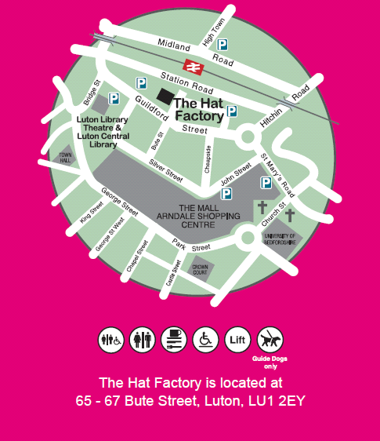

The Hat Factory is a short walk from Luton station (not Luton Airport Parkway station).

