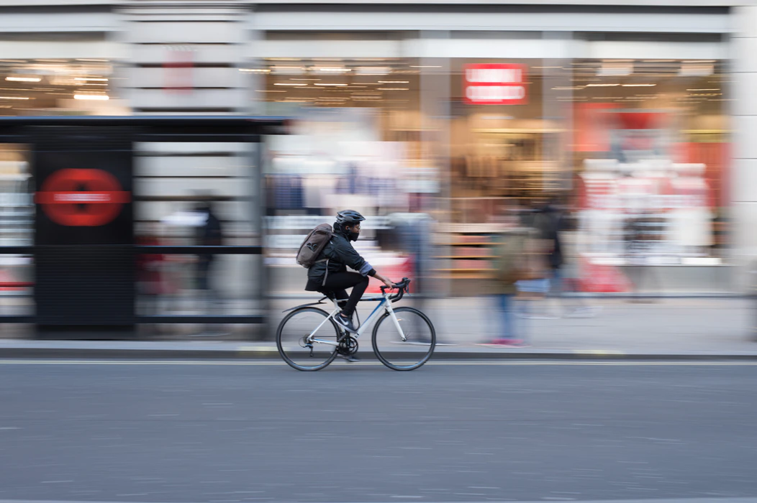
Active Travel
The voice of London’s transport users
Guide to having your say on recent changes to London’s Streets

Contents

Introduction 2
FAQs: what is Active Travel, and what is happening to London’s streets? 4
How can I have my say? How to feedback about changes 11
Glossary 19
Useful links 22
References and credits 23

Tip: terms written in green throughout this guide are defined in the glossary at the end.

This guide is also available in a plain text version and as a PDF.

Introduction

There have been lots of changes to London’s streets in the last five months, including the introduction of road barriers, plastic bollards and planters. The purpose of these changes was to help enable social distancing and make it easier for people to walk and cycle during lockdown. In London, this is all part of a programme of changes called ‘Streetspaces for London’ which is being run by Transport for London (TfL), with the hope that more people will use Active Travel modes to get around. We’ve tried to answer some frequently asked questions (FAQs) on what Active Travel actually means, outline some of the changes you might see and explain how you can comment, feedback or recommend suggestions to your local authority or TfL. At the end of the guide you will find a glossary which explains some of the terms we use.
Generally you should contact your local council and councillors as they will either be responsible for streets changes, or know the authority that is and can redirect you. We have created a contact page so you know who to get in touch with in your borough, which can be found here on our website.
Who we are
London TravelWatch is the independent, multi-modal body set up by Parliament to provide a voice for London’s travelling public. This includes users of rail services in and around London, all TfL services (bus, Tube, DLR, trams, taxis) and motorists, cyclists and pedestrians using London’s strategic road network. We are funded by and accountable to the London Assembly.
Our aim is to press for a better travel experience for all those living, working or visiting London, and its surrounding region.
We have created this guide to help transport users understand the changes that are happening, simplify some of the jargon and help you to have your say. We will continue to update the information we have as things change, and you can stay up to date by signing up to join our transport user community.

FAQs: what is Active Travel, and what is happening to London’s streets?

What is Active Travel?
Active Travel refers to modes of transport which are physically active, or better for the environment: so walking, cycling, wheeling and also micro-mobility like e-scooters. There are many benefits to more active travel, and the Government, local authorities, TfL and the Mayor of London are all keen to encourage more people to use Active Travel to make journeys where possible.
Ordinarily, the term ‘Active Travel’ might include public transport use, such as the bus, train or underground. However, because we are now required to socially distance in public spaces, transport users are being encouraged to walk or cycle if possible to ensure that public transport remains less busy for those who need to use it. For this reason, many of the Active Travel measures you may have seen will be focused on making streets safer and easier to walk and cycle on.
Why the push for walking and cycling?
Walking and cycling is being encouraged because more often these types of journeys are done locally, and can also replace some private car and public transport journeys. This in turn will mean those that have to use public transport will be able to do so more safely, as there will be more room for them on the bus or train, for example.
What’s happening on my street with all of these barriers and poles that are being installed?
TfL and local councils across the country have been asked to do what they can to make more space on their streets available for social distancing in order to reduce the spread of the coronavirus. The Government also wants changes made to streets to encourage more walking and cycling, to help reduce the number of private car journeys and reduce demand for public transport.
What ‘Active Travel’ changes are happening in London?
There are a number of measures being used to encourage and facilitate Active Travel, but other policies and measures may be implemented alongside to help people to walk and cycle more. The main measures being introduced by London boroughs and TfL as part of the Streetspaces programme are:
Pavement widening
Pedestrians are being given pavement space on the road to allow for social distancing, which is usually protected by temporary barriers. At some bus stops the pavement is being widened to allow for social distancing whilst passengers wait for the bus.
Enhancing the cycle network
Temporary or ‘pop-up’ cycle lanes are being installed to encourage cycling. You might have seen temporary barriers or ‘wands’ – posts in the ground – to separate these new cycle lanes from other vehicles.
Traffic control measures
Some roads are being closed to through traffic to create ‘Low Traffic Neighbourhoods’ (LTNs) with the aim of providing better walking and cycling environments. In other places, general traffic is being restricted to prioritise buses, cycles, and walking.
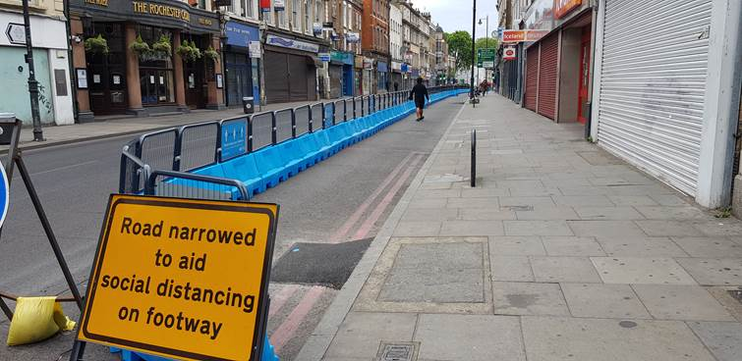

How does this affect me and what can I do to have my say?
It is hoped that people will generally be safer using the streets when walking and cycling for their local trips to school, the shops and visiting friends and family. Some people may feel disadvantaged by these changes and want to comment or object to them. Some may feel there is a lot more to be done in their area, but haven’t seen any change yet.
Because these are temporary changes, the legal process only allows people to make comments during the period of time they are in place. Only after considering any comments will the authorities decide whether or not schemes should stay in place or be removed.
Later in this guide we describe the different kinds of schemes you might come across, and explain how you can have your say.
Will these schemes end up being permanent?
These schemes are being implemented either as temporary or experimental changes. So some will have end dates and be removed, but for others there could be further consideration, in a few months time, as to whether they become permanent or not. This will be judged on whether they are a good fit for London, and whether they help to encourage more walking and cycling as part of the Mayor of London’s transport strategy.
There is an opportunity for residents to comment on these schemes now as they are being installed experimentally or temporarily, using temporary materials. Changes can be made or the scheme could be removed altogether. A lot of the changes happening now will be decided upon in the next few months, so now is the opportunity to feedback.

What’s happening on my high street with all of these barriers and poles that are being installed on the roads?
You may have seen barriers in the road that allow pedestrians to spread out more. These have often been installed near supermarkets where queuing shoppers are waiting and allow others to pass by safely in the newly expanded pavement.
Alternatively the barriers could be what are being called ‘pop-up cycle lanes’ to allow safe space for cyclists on the road.
At my local bus stop they have extended out the bus stop. It looks permanent. What’s going on?
At a few of the very busiest bus stops the pavements have been extended to have a wider width of tarmacked space. This is to allow bus passengers more space to wait for their bus and safely socially distance.
I’m worried access is not being considered, as some of the temporary street changes have not been accessible.
A number of concerning issues have emerged as a result of the temporary measures, with some schemes limiting or restricting access for some users of the streets, including disabled people. For example, pavement widening schemes can help with crowding and street clutter, but only when they are accessible; there should be access ramps and dropped kerbs to the widened area, and they should not block crossings, bus stops or taxi pick-up areas. Another measure being used is the creation of car-free zones and low traffic neighbourhoods: these become inaccessible to those for whom car travel is the only accessible mode of transport. We know that changes to the street can be worrying to a wide range of people, and can cause anxiety and uncertainty, especially when these changes are not communicated well. Many of these changes have been brought in rapidly as a response to the Covid crisis, and in some case with no consultation, which has resulted in restricted or reduced accessibility.
What can I do?
As we outline later in this guide, anyone who wishes to comment or make suggestions to their local authority about streets changes can contact their council representative or their local councillor to feedback on any aspect of the changes. You could try and raise awareness about access needs with your local council and councillors, and stress that they need to manage these changes considering everyone’s needs.
However, London TravelWatch do not think the onus should be on disabled people and those with mobility needs to notify their authorities about instances where access has been limited. Your local authority should be completing assessments of whether these changes will negatively impact access and consulting with local residents to find solutions which don’t limit access.
Unfortunately, the quality of consultation with local residents varies greatly across London authorities, and London TravelWatch think there needs to be improvement in the way TfL and local authorities consult on changes to streets.
We have been working with Transport for All, a campaigning organisation who represent disabled and older transport users, to get a better understanding of the access issues that are arising as a result of the recent changes to London’s streets. We support Transport for All in their call for better quality consultation on streets changes and the inclusion of for robust and co-produced Equality Impact Assessments for all proposed changes to London’s streets.
If you have a particular issue or experience you would like some advice on, you can contact Transport for All – you can find their contact details at the end of this guide. They will be able to help identify what the problem is, and what the next steps might be. Transport For All are also building up an evidence base of stories and data from disabled people experiencing difficulties with changes to street space, and are encouraging people to get involved by sharing examples of the impact street design. Perhaps a local road closure has meant you need to take a detour to work, or perhaps uneven pavements or street clutter has made going to the local shops more difficult for you. You can share examples on social media using the hashtag #PaveTheWay, or get in touch with them directly by contacting their Access, Rights, Advice line.
Alternatively, London TravelWatch represent all users on TfL’s network, which includes the roads on the Strategic Road Network that TfL are responsible for, like Euston Road, for example. So if you have contacted TfL about an issue on one of their roads and are unsatisfied with the response you receive, you can appeal directly to us. More details about how to appeal can be found here.
The council has introduced barriers at the end of the road near where I live and I can now no longer get in and out of the street I live in. Why have they done this?
Your local council has been asked by national and London government to rapidly improve the local cycling environment to encourage people to take up cycling or cycle more, perhaps even to their place of work. This is because there will be very little capacity on public transport and certainly not enough for everyone, particularly at peak times. They also want to discourage short car journeys. One of the ways to do this is to restrict through traffic on minor residential streets. This creates ‘low traffic’ areas that are better for cycling.
Whilst these schemes do restrict access to properties there should be access to your property from one side of the closure or the other, though for some this may be less convenient than previously.
The council has stopped traffic going down a nearby street by introducing barriers. There is now more traffic on the street I live, causing congestion problems. Why have they done this?
Whilst it will be the case that some of the traffic is directly displaced into neighbouring streets, particularly early on as drivers adapt to the new situation, it is considered that the main road network is the best place to be able to manage this traffic.
That said it may be necessary and possible to make further changes in the area and so you should comment on the scheme to your local council and councillors.
I’ve seen lots of changes in other areas of London, but nothing in my neighbourhood. How can I make a suggestion to improve active travel in my area?

It’s true that some boroughs are doing more than others. The Government and TfL were keen to support schemes that could be implemented in weeks rather than months, which is why some areas have seen much more in the way of streets changes. They agreed funding with those that had already developed schemes and acted quickly. The situation is still developing in terms of additional funding to local authorities, but if you have ideas you should definitely get in touch with your local councillors. You will find their contact details on your council’s website. If you can get support from neighbours for your ideas and start a letter writing campaign or petition that would help make a stronger case for any change.

How can I have my say? How to feedback about changes
Who is making the changes?
There are 34 different highway authorities in London: TfL, the London boroughs and the City of London. Highway authorities are responsible for managing road networks, including which vehicles are allowed to use the roads, and at which times they may do so.
These highways authorities all approach consultation on highways schemes slight differently, reflecting the scale of the changes and the different priorities of the area the changes are happening in. Not all highways schemes need orders, just the ones that change how the road is used. So, for example, the plastic poles that protect cycle lanes can be introduced without any legal process.
For larger schemes an informal consultation will happen before the legal or statutory process (we explain this below, see page 13).
For smaller schemes the authority will rely solely on the legal process.
What is the legal requirement in terms of consulting with people and making changes to roads?
In this crisis, just as in ordinary times, the highway authority will have to carry out a legal process called a traffic order that defines what type of vehicle can use a section of road and for what purpose. There are three ways in which this can be done, although in some cases there has been some relaxation of the consultation requirements so that schemes can be put in quickly.
Normally, consultation with residents and transport users might happen over a longer period of time, with notices in local papers, letters and site notices as well as online consultation. However, lots of the schemes you have probably seen have been consulted via online means only, and some of the timescales have been quite short. Consultation that has usually been done with notices in local papers, letters and site notices could be replaced by online publication. The Government’s guidance on the consultation requirements has changed during the Covid-19 crisis.
We think it is useful for you to know the different types of traffic orders being used to make changes, as it will give you some idea of how your highway authority should be consulting on these changes and knowing when is your opportunity to feedback. You can find out what type of traffic order the change you are interested in is by looking at your council website or the TfL consultations page (we explain this more a bit later on).
There are three types of traffic order that your highway authority might use to make changes in your area. We have outlined below what these are, and the sort of consultation they will have to hold for them:
The Permanent Traffic Order
This is a legal requirement and will usually follow on from an informal public consultation. It’s the normal method of making changes to what type of vehicle can or cannot travel, park or turn on parts of the road. There should be a 21 day opportunity to have your say on these changes. If you miss that you can still contribute, as the authority might still consider your points.

Experimental Traffic Order
As it sounds, this is the way a highway authority can try something out before it decides whether to make it permanent or not. There are timescales they must stick to, and the experimental order can’t become permanent without consultation. There should be a formal seven day notification period before the change is put in. The time you have to contribute will usually match up with how much time the change will be in place for. At the end of the period (maximum 18 months), or earlier, the authority must make a decision about whether they want the change to become permanent or abandoned.
Temporary Traffic Order
Again as it sounds, these changes should be temporary. These orders are normally used to close a street for crane works to a building, for safety reasons or for litter clearance. Some authorities are expanding the definition of Temporary Traffic Orders to make changes to traffic operations for Covid-related safety reasons. Again, there is a seven day period of notice and there should be a stated end point, at which time traffic operations go back to normal.
Equality Impact Assessments
For some of these schemes, the highway authority may decide to carry out an Equality Impact Assessment (EIA).
EIA’s are assessments that public authorities carry out before implementing policies, to measure and assess their impact on equality. The Equality Act 2010 does not specifically require them to be carried out, although they are a way of facilitating and showing compliance with the Public Sector Equality Duty (PSED).
London TravelWatch believe EIA’s should be carried out for changes to the street. As mentioned earlier, we support Transport for All in their call for robust and co-produced EIA’s to be carried out in consultation with local users for all streets changes, to avoid limiting the access of any groups or individuals.
Where can I find out what changes are happening?
The biggest issue in having your say on these interventions is knowing, first of all, that they are happening. There are likely to be a few places you may find information before the proposals are implemented. If in doubt you can contact your local council’s highways or transport service to find out about streets changes in your area.
Keep checking the relevant sources
You should keep your eye on council websites, the TfL website, newspapers and site notices. Council websites often have consultation pages on which you will find details of the different changes they are considering, and what type of traffic order they fall under.
TfL Consultation Hub
TfL’s consultation hub and ‘Streetspace’ proposals are at: https://consultations.tfl.gov.uk/ providing a full list of TfL schemes.

Sustrans website
Sustrans are a UK Charity whose aim is to make it easier for people to walk and cycle. The Sustrans website mapped some of the early schemes that have been delivered as part of their ‘Space to move’ campaign. They are soon due to launch a joint map with TfL of all the streets changes that are happening in London, providing people with a way to feedback on the changes featured. We will update this on the guide once this map goes live.
Who controls the street I am interested in?
It is important to know if the proposal you are interested in is on a street controlled by your local council or TfL, as this will mean the way you feedback is different. If the road you are interested in has yellow lines painted on the street it is a local council street. If it is a TfL-controlled road there will be red line markings indicating it’s a TfL ‘Red Route’.
If you are unsure, you should contact your local council’s highways or transport service and they should be able to tell you.
Who should I contact?
Once you have determined who the highway authority is you will need to contact them. This could be via an online tool associated with the proposal, or you could email the highways department or general contact details of the council with your feedback. The format will vary by authority. We have created a list which you can use to find out who your contact is.

For local authority schemes, you could:
- Write to your local councillor. Their email address and other contact details will be on the council website.
- Email the highways department or general contact details of the council.
- Write to the Leader of the council or the executive (not civic) mayor where there is one.
The London Councils website https://directory.londoncouncils.gov.uk/ has an accessible list of all council contacts. There is also a list of councillors that form an Executive (the main group of decision-making councillors for each borough). One of these will lead on transport.

For TfL schemes:
- If the proposal is on a TfL/Red Route you should contact TfL via their email address: streetspacelondon@tfl.gov.uk
- Or you may want to write to the Greater London Assembly elected member. These elected members will cover more than one London borough. The contact details will be on their website including the boroughs they represent at: https://www.london.gov.uk/people/assembly.
If you don’t spot the proposal before it is implemented, this doesn’t mean you shouldn’t let your views be known. These changes are currently temporary and should be able to be moved, adjusted or improved.
What might you say?
The most important thing to say is how the proposal affects your or others’ use of the street. Do they act as a barrier (physical or otherwise) to getting around by whatever form of transport you want to use? Do you like the changes, but think they can be improved if changed or designed slightly differently? These are all important considerations.
These interventions could be there for a long time and so should be useable by everyone, and we encourage all transport users to have their say.

Glossary

Transport User
London TravelWatch regards all those who travel in and around London as transport users, whether passengers of rail, bus, underground, DLR or tram, or users of the streets including pedestrians and cyclists.
Active Travel
Active Travel refers to modes of transport which are physically active, or better for the environment: so walking, cycling, wheeling and also micro-mobility like e-scooters.
Mayor of London’s Transport Strategy
The Mayor's Transport Strategy sets out his plans to transform London's streets, improve public transport and create opportunities for new homes and jobs. To achieve this, the Mayor wants to encourage more people to walk, cycle and use public transport. The transport strategy is a formal policy document used to guide TfL policy.
Consultation
In this context, consultation is the process via which the highway authority will discuss proposed changes with local residents and transport users, to find out their views and any concerns they may have. This is an important part of any changes to the streets or public environment. Some types of consultation are compulsory or must be carried out for legal reasons, while others are optional.
Informal consultation
This is a type of consultation that is not a legal requirement, but is useful for finding out the views and opinions of people before or during changes to streets. Informal consultation can help highways authorities identify areas to prioritise, or flag any concerns early on.
Equality Impact Assessments
Equality Impact Assessments (EIA) are assessments that public authorities carry out before implementing policies, to measure and assess their impact on equality.
The Equality Act 2010
The Equality Act 2010 legally protects people from discrimination in the workplace and in wider society. It replaced previous anti-discrimination laws with a single Act, making the law easier to understand and strengthening protection in some situations.
The Public Sector Equality Duty (PSED).
The Public Sector Equality Duty (PSED) requires public bodies to have due regard to the need to eliminate discrimination, advance equality of opportunity and foster good relations between different people when carrying out their activities.

TfL’s Strategic Road Network
Responsibility for managing London's road network is shared between TfL, Highways England, and the 32 London boroughs, plus the City of London.
TfL manage the Transport for London Road Network (the TLRN or London's 'red routes') and the London boroughs are responsible for all the remaining roads within their boundaries.
Red routes
London's red routes are a network of key routes such as the A40 or A406 (North Circular Road).

Legal or statutory process
This means the steps which must take place to make legal changes to the streets, and is required by law. It will include some element of consultation, for example, and requirements for how long that consultation needs to last before making a decision about permanent changes.
Highway
The highway is a way or place which is publicly maintained and open to the use of the public to travel in a variety of vehicles. Highway includes the street.

Highway authorities
The highway authority, which is usually the council, has a duty of care to maintain the safety and usability of roads that are kept at public expense.
There are 34 different highway authorities in London: Transport for London (TfL), the London boroughs and the City of London. Highway authorities are responsible for managing road networks, including which vehicles are allowed to use the roads, and at which times they may do so.
Traffic order
As was discussed on page 13, traffic orders are legal agreements which allow highways authorities or the police to enforce regulations including speed limits, on-street parking and one way streets. Most traffic orders are created with input from local communities and the police, to address specific traffic congestion or quality of life issues.
See page 13 for details of the different types of traffic orders that may be used to make streets related changes under the Streetspaces programme.

Useful links

London TravelWatch resources:
Council contact details
Appeals information:
https://www.londontravelwatch.org.uk/complaints/complaints_and_appeals_about_streets_issues

Transport for All:
https://www.transportforall.org.uk/
Transport for All helpline:
https://www.transportforall.org.uk/helpline/

TfL Streetspaces programme:
https://tfl.gov.uk/travel-information/improvements-and-projects/streetspace-for-london

Sustrans ‘space to move’ campaign:
https://www.sustrans.org.uk/space-to-move

Link to London Councils’ councils directory:
https://directory.londoncouncils.gov.uk/

References and credits

Images
Front page photo credit: Roman Koester https://unsplash.com/photos/v53RV9LL5y0
All other photographs used are London TravelWatch’s own
